## Light spectrum of lamp

### Theoretical background

The optical spectrum of a chemical element is the result of the transition of an electron from a higher to a lower energy level of atoms, accompanied by the emission of a photon. The frequency of the emitted photon depends on the energy difference between these levels and can be measured using spectroscopy. It is well known that the set of spectral lines is individual for different materials and can be used to determine the chemical composition of substances.

Before using the spectrometer must be calibrated. It is necessary to calibrate the intensity (height) and wavelength of the spectral lines. The black body can be used as a reference radiation source since spectral density of electromagnetic radiation (intensity) of an absolutely black body depends only on temperature and is described by Planck's law (1)

$ε(λ,T)=\frac{2hc^{2}}{λ^{5}}\frac{1}{e^{\frac{hc}{λkT}}-1}$ (1)

where ε (λ, T) is energy emitted from one square meter per one second per unit region of wavelengths, T – body temperature, λ - wavelength, h – Planck’s constant, c – speed of light and k -Boltzmann constant. This function can be used to calibrate intensity (spectral line height) of spectrometer on different wavelengths. For intensity calibration, wolfram lamp can be used which acts as a black body at temperature T = 1700K. The calibration formula looks like this:

$I\left(λ\right)=\frac{ε(λ)}{I_{E}\left(λ\right)-I_{p}(λ)}∙(I_{m}\left(λ\right)-I_{p}\left(λ\right))$ (2)

here $I_{E}$ (λ) - is lamp intensity, $I_{m}$ (λ) - incoming signal from spectrometer and $I_{p}$ (λ) - spectrometer intensity in the dark. Result of calibration is represented on Figure 1.

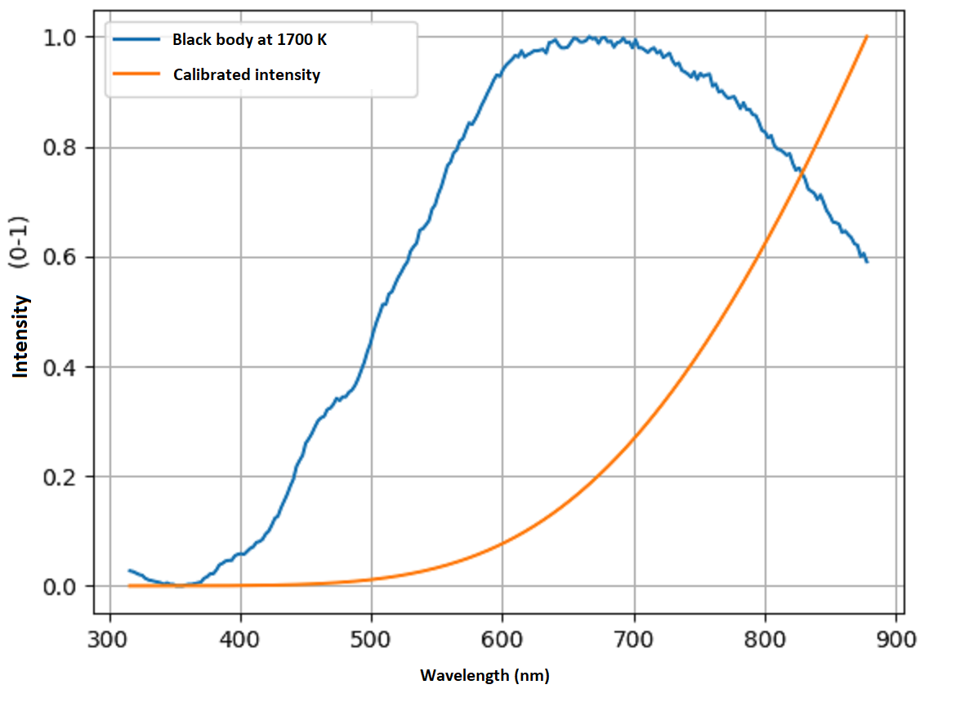

Figure 1 - Calibration of y-axis (intensity)

For x-axis wavelengths calibration, used hydrogen and mercury lamps with known spectral lines (see Figure 2 and Figure 3).

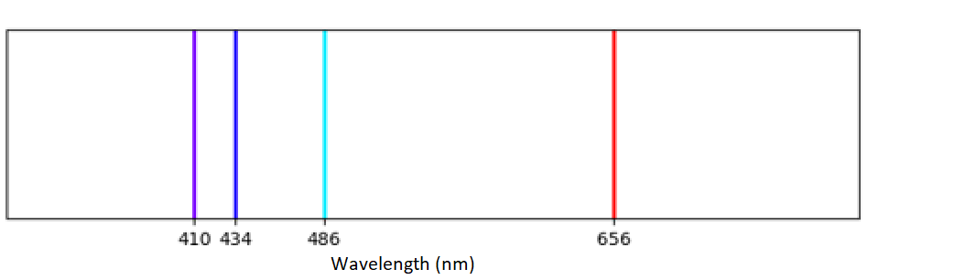

Figure 2 - Spectral lines of Hydrogen

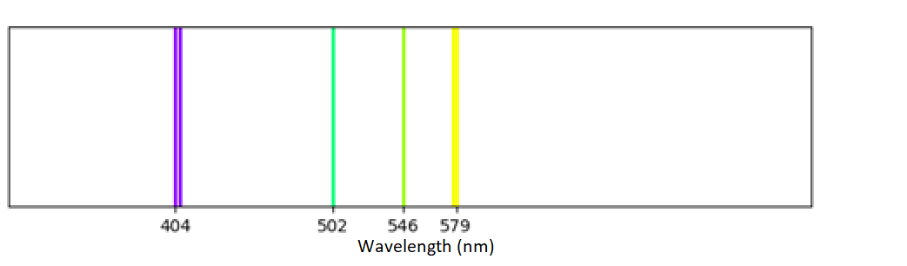

Figure 3 - Spectral lines of Mercury

Then, the channel number of the spectrometer is mapped with the corresponding spectral lines of the reference lamps. The calibration line is presented on Figure 4.

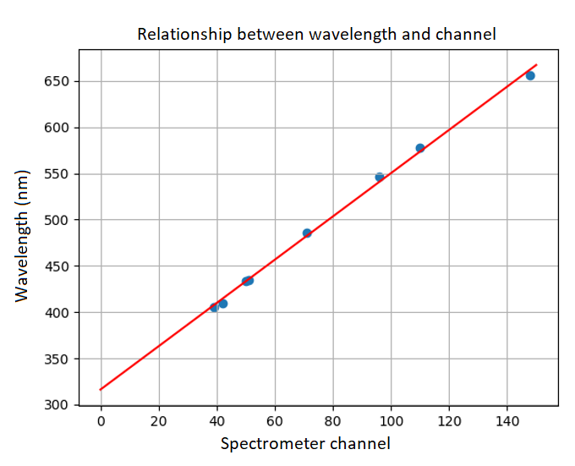

Figure 4 - Calibration of channels and wavelengths

### Laboratory instrumentation

Physical equipment used in lab: Arduino UNO R3, Hamamatsu C12880MA spectrometer and sample lamp. Spectrometer is attached to Arduino and connected to computer via USB cable from where software reads sensor data. Simplified diagram of laboratory structure is described on Figure 5.

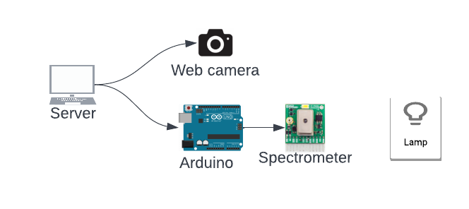

Figure 5 - Hardware components for spectrometer laboratory

Spectrometer has 288 channels which correspond to intensity per wavelength. To know exactly which channels correspond to which wavelength, it is necessary to calibrate spectrometer. For calibration, Hg and $H_{2}$ lamps can be used because they have easy to be determined spectral lines. Linear regression can be used to determine parameters of line (slope and intercept) that convert spectrometer channel to wavelength.

### How to use laboratory

Steps to use laboratory:

* Start spectrometry lab.
* Click ‘Start measurement’, so spectrometer sensor will start sending data and spectrum gets automatically plotted.
* Save measurement results and leave spectrometry lab.
* Using table with known spectral lines, find what chemical element lamp contains.